|  |
| --- |
| TRINITY INTERNATIONAL COLLEGE |
| CASE STUDY 2: |
| OVERVIEW OF PLANNING |

|  |
| --- |
| Samrajya Chand  20th Shrawan,2080 |



1. PROCESS OF IDENTIFYING AND SELECTING DEVELOPMENT PROJECTS

* Consists of 3 primary activities:

1. Identifying potential development projects
2. Classifying and ranking projects
3. Selecting Projects for development
4. Identifying potential development projects

* Consists of :

CEO, member of top management.

Managers, with interest in system.

Department in which head of requesting committee decides project Submit.

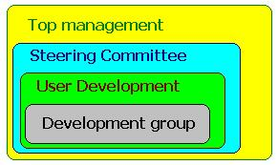

1. Classifying and Ranking Projects

* Assessing the merit of project is 2nd most major activity in the phase.
* The process can be performed by the same individuals that performed the previous one.
* Criteria used to assign merit may vary with organization.
* 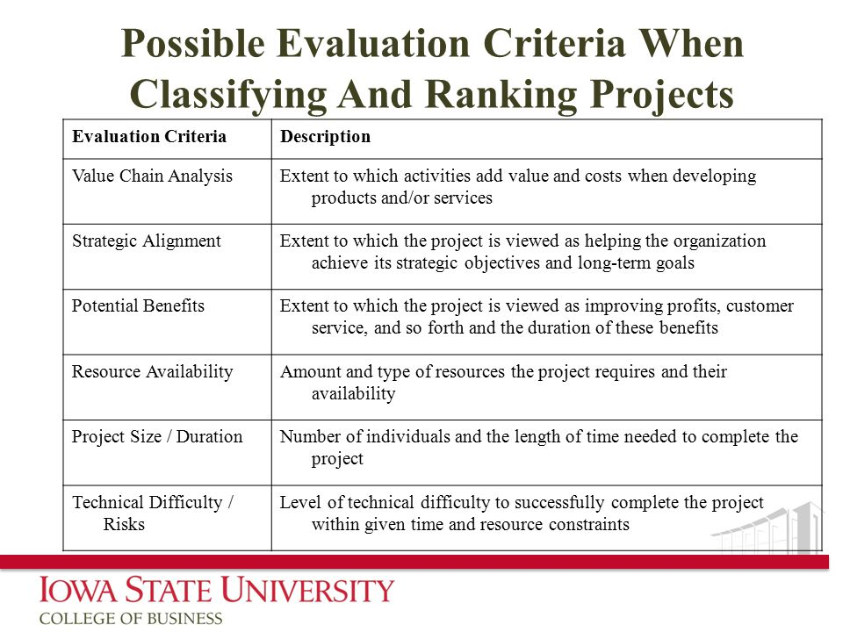The possible criteria are:

1. SELECTING IS DEVELOMENT PROJECTS

* Final activity in project identification & selection phase.
* Short & long term projects are most likely to achieve business objectives.
* 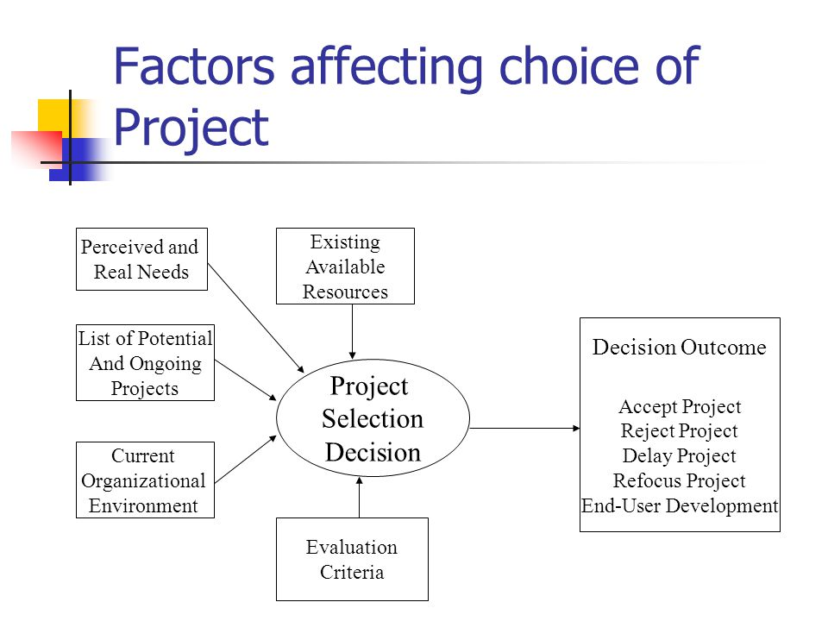As business conditions change over time the relative importance of a project may also change.

1. CORPORATE STRATEGIC PLANNING

* Prerequisite for making effective project selection decisions is to gain a clear idea if where organization is, its vision of where it wants to be in future, and how to make transition to its desired future state.
* It is an on-going process that defines the mission, objectives and strategies of an organization.

GENERIC COMPETITIVE STRATEGIES

1. INFORMATION SYSTEM PLANNING

* 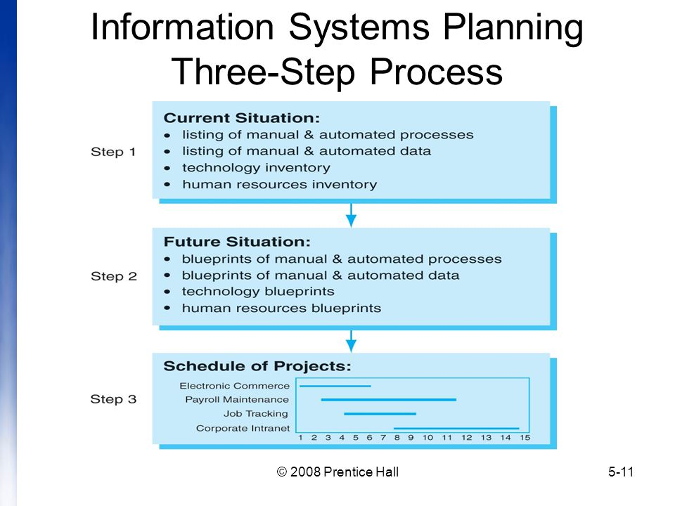It is an orderly means of accessing the information needs of an organization and defining the information systems, databases, technologies that will best satisfy those needs.

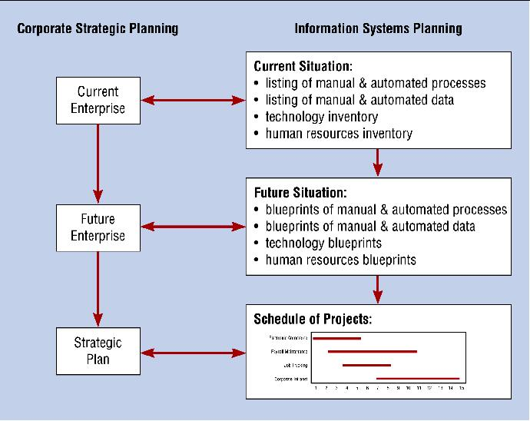

Parallel activities of corporate & Information system planning

1. Describing Current Situation:

* 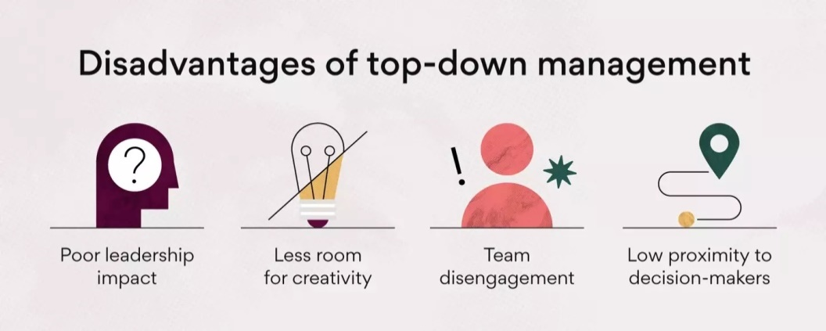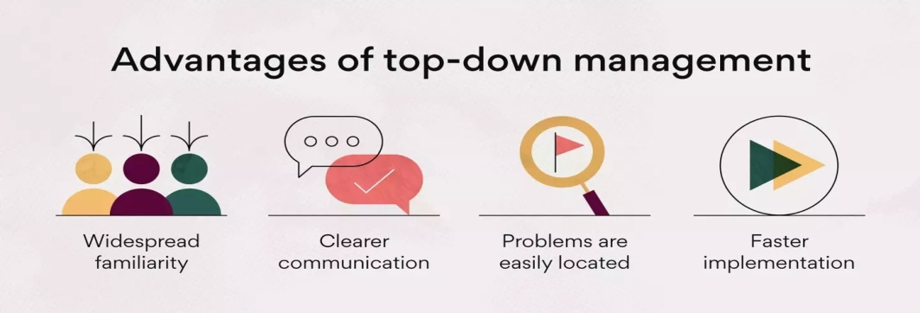Most widely used approach for describing current organizational situation is top down approach its advantages over others are:

1. Describing Target Situations,trends,Constraints

* Defining the target situation that reflects desired future state of organization.
* This means target situation consists of desired state of location, units, functions, processes, data and IS.

1. Developing a Transition Strategy and Plans

* Once the creation of current and target situation is complete, a detailed transition strategy and plan are developed by IS planning team.

1. INITITATING & PLANNING SYSTEM SEVELOPMENT PROJECTS

* During the phase of SDLC planning, two primary activities are performed.
* First, Project identification & selection, focuses on the activities during which the need for a new or enhanced system is recognized but doesn’t deal with specific project.
* Next step is to conduct a more detailed assessment during project initiation and planning.
* Most organization assigns an experienced system analyst to perform project system and planning.

1. PROCESS OF INITITATING & PLANNING IS DEVELOPMENT PROJECTS.

* Activities performed during project initiation are:

1. Establishing project initiation Team
2. Establishing relationship with the customer
3. Establishing Project Initiation Plan
4. Establishing Management Procedures
5. Establishing Project Management Environment
6. Developing project Charter

* Activities performed during project planning are:

1. Describe project scopes, alternatives
2. Dividing project into manageable tasks
3. Estimating resources & creating resource plan
4. Developing preliminary schedule
5. Developing communication plan
6. Identifying and accessing risk
7. Setting a baseline project plan
8. DELIVERIES & OUTCOMES

* The major deliveries and outcomes from project initiation and planning are the baseline project plan and project scope statement.
* The Baseline Project Plan (BPP) contains all information collected and analysed during project initiation and planning activity.
* The Project Scope Statement is a short document prepared for the customer that what project will deliver & outlines all work required to complete the project.

1. ASSESSING PROJECT FEASABILITY

* Assessing project feasibility is a required task that can be a large undertaking because it requires a system analyst to evaluate a wide range of factors.
* Most feasibility factors fall into the following categories:

1. Economic
2. Operational
3. Technical
4. Schedule
5. Legal & contractual
6. Political
7. ASSESSING ECONOMIC FEASABILITY

* Its main purpose is to identify financial benefits and costs associated with development project.
* It is often referred as cost-benefit analysis.

1. Determining Project Benefits:

* Information system can provide many benefits to an organization.
* Benefits are both tangible and intangible
* Tangible refers to the items that can be measured in dollars and with certainty.
* Intangible refers to items that cannot be easily measured in dollars or with certainty.

1. Determining project costs:

* One-goal of cost-benefit analysis is to calculate the total cost of ownership (TCO).
* TCO refers to cost of owning and operating a system, including total cost of acquisition as well as cost associated with its on-going use and maintenance
* A one-time cost refers to a cost associated with project initiation and development and the start-up of system.
* A recurring cost refers to a cost resulting from the on-going evolution and use of system.

1. The Time Value Of Money

* Most technique used to determine economic feasibility encompasses this concept.
* TVM refers to comparing present cash outlays to future expected returns.
* Present value is current value of a dollar at any time in future .It can be calculated using:

PVn =Y *(1/ (1+i)n

* Here, PVn is present value of Y dollars n years for now when I is discount rate
* TO calculate NPv we simply add present values calculated previously.
* The objective of Break-even analysis is to discover at what points (if ever) benefits equals to costs.
* Break-even ratio =(Yearly NPV cash flow – Overall NPV cash flow)/Yearly NPV cash flow

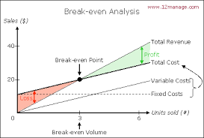

1. BASELINE PROJECT PLAN

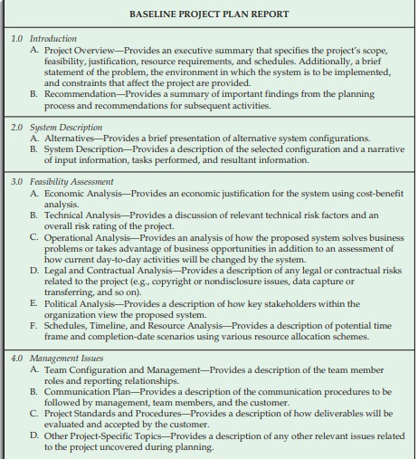

1. REVIEWING BASELINE PROJECT

* Before the next phase of SDLC begins users, management, development group must review the BPP in order to verify that it makes sense.
* A common method for performing this review is structured walk-through.
* Walk-Throughs are peer group reviews of any product created during the systems development process and are widely used by professional development organizations.